**The Choice of Partner –**

**National Influence Factors on the Founding of Sister Cities**

Manuel Kleinert

Justus-Liebig-University Giessen, 2019

*Seule Paris est digne de Rome; seule Rome est digne de Paris.  
Solo Parigi è degna di Roma; solo Roma è degna di Parigi.*

„Only Paris is worthy of Rome; only Rome is worthy of Paris.“

(City of Rome 2016)[1]

ABSTRACT

Sister cities are a possibility for cities to connect themselves within a globalized world. This paper elaborates which national factors are decisive for cities to pair with others. Initially, several potentially important factors which could influence the number of twinnings between two countries were identified theoretically and according hypotheses were formulated. These assumptions were tested by applying a mixed methods design. Initially, the global network of sister cities was mapped visually in a network analysis approach. A qualitative analysis of this network suggested that proximity, historical and cultural bounds are especially relevant national factors that drive the foundation of such partnerships. In a second step, these variables are tested quantitatively. A shared border, trade, and a history of war proved to be relevant factors influencing the decision on where cities look for partners.

**INTRODUCTION**

Cities have become the centre of social and economic progress. They are also engaging with each other on a subnational level in various cooperations. Their most developed and dense cooperation is through the founding of twinnings between cities. Recently, these connections have received more attention. However, still many aspects of where cities look for ‘twins’ are yet unknown. This paper aims to elaborate which factors are decisive for cities to engage in twinnings.

A two-layered research design including a graphical network analysis, followed by a detailed regression analysis is presented. The last part summarizes main findings and concludes the study, it also reflects about the applied methods and the robustness of the findings.

A rather implicit research question will also be: Were the twinnings established to further deepen already established relationships (deepening hypothesis) or to overcome former hostility or rather establishing new contacts (contact hypothesis)? One could either avoid contact to former enemies and colonial powers or try to reconcile with exactly these countries through the foundation of sister cities. A similar case are colonial relations. Especially possible in both directions is cultural similarity. Either cities try to deepen contacts with culturally similar regions or they see twinnings as a low-threshold On the other hand, contacts to close partner states might not rely on such partnerships. Where variables could exert influence in both directions, competing hypotheses were formulated.

**LITERATURE REVIEW: INFLUENTIAL FACTORS ON THE CITY LEVEL**

Twinnings between cities were studied from different perspectives. Those can be grouped in several influential factors.

*Geography*. Many studies have highlighted the importance of geographic closeness for town twinnings (Bussmann and Nickel 2018; Zelinsky 1991). Zelinsky (1991) shows this convincingly, using the example of France (see Graph 3). Especially those regions with direct borders or proximity to neighboring countries engage in twinnings with these. Sea or land borders make no difference in this example.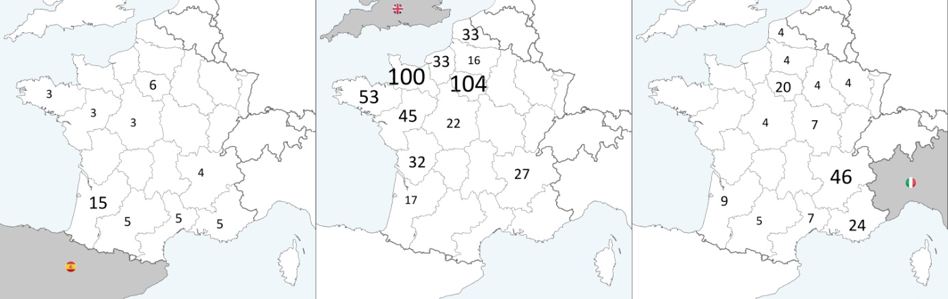

Figure 1: twinnings of French regions with neighbouring countries in 1988[2]

However, this factor is highly entangled with historical, political and economic reasons and thus, closeness as a reason for engaging in twinnings may not always be an end in itself. Others also show, that great distance is no obstacle and that closeness has only a “negligible influence” (Kaltenbrunner et al. 2013). Various other geographic attributes can also be decisive in some cases. These include being located in a snowy region, or on the same canal (Zelinsky 1991).

*War and reconciliation.* Town twinnings flourished especially in Europe in the aftermath of World War II. Such sub-national connections with regular exchanges were perceived as a key policy in establishing ties with former enemies (Bussmann, Nickel 2018; Grosspietsch 2009). In 1988, most partnerships of Germany were linking it to France and the United Kingdom; Israel also had its thickest connection with Germany; Japan had most sister cities in the USA and China (Zelinsky 1991). Even if there is no national policy backing it, reconciliation is sometimes driven by local authorities. Nicaragua´s most important twinning partner during the Contra War was the USA, a sign of solidarity of some local mayors, who opposed the national policy at that time (Zelinsky 1991). Twinnings can therefore be regarded as a possibility to engage with people from different political backgrounds, when official national contacts are hard to realize or justify (Ude 2012)[3]. In the aftermath of World War II, these ‘reconciliation ties’ also helped reconstruction of Continental European Cities through humanitarian aid and technological support (Cremer et al. 2001; Clarke 2011). More recently, the decline of the East-West divide and a deepening of European integration spurred twinning between towns, e.g. in the Baltic region (Bussman, Nickel 2018).

Such connections may indeed be linked to an intended policy and not simply to geographic proximity, as can be illustrated by several counterexamples. As of 1988, no twinnings were established between India and China, India and Pakistan, North and South Korea or Turkey and Greece, although all of them share a common border (Zelinsky 1991, p. 14, 20).

*Colonial history*. Historical bounds also play a key role in twinnings between cities with the same name. This is a well-known phenomenon, in which especially American, Australian or Canadian towns twinned with their European counterpart, very likely the native home of their first settlers (Zelinsky 1991; Cremer et al. 2001). This ties in with colonization, as another historical connection between many countries, which is regarded as a supporting factor in establishing twinnings today (Joenniemi and Jańczak 2017; Kaltenbrunner et al. 2013). However, former colonization is also highly entangled with cultural similarities, like religion and language, which are factors on their own, as explained below. Previous studies ignoring these aspects, therefore may have overestimated the isolated effect of colonization. An example illustrates this point: Zelinsky is irritated by the fact that in 1988 there was no partnership between the Netherlands and Indonesia (1991, p. 21). The reasons for this might be the difference in language, religion or the particularly long and bloody fight for independence after World War II.

*Economy*. Many studies dealing with town twinnings focus on their economic impact. Twinnings yield considerable advantages in terms of efficient and sustainable governance (Cremer et al. 2001; Payre 2010; Capello 2000). Economic development and investments are also enhanced when such cooperation is established (Hu et al. 2016; Villiers et al. 2007).

*Culture*. Cultural interactions are often hard to separate from economic aspects and interests. For example when economy has profoundly shaped a city´s history, evident in the twinning between textile cities Troyes (France) and Tournai (Belgium) (Zelinsky 1991). Deep entanglement of cultural, political and economic interests are also visible in China´s efforts to establish twinnings with western countries (Qing et al. 2020; Cremer et al. 2001); or in tourism, as Cohen´s (2020) research on travel between sister cities highlights. His results suggest that religion may play a role in twinning choices and exchange. Others have also highlighted, that similarities in culture, ideology and development are crucial factors for establishing ties (Baycan-Levent et al. 2010; Kaltenbrunner et al. 2013). Such patterns of homophily are well-known phenomena in network analyses (McPherson 2001).

However, apart from face-valid but rather arbitrary classifications of individual researchers (Huntington 1997), there is no straightforward, well-established quantitative index of cultural similarity. Nevertheless, existing research was highly interested in capturing culture in categories applicable across different countries (Schwartz 2008, Hofstede et al. 2010). Their values can be used to compute a dyadic measurement of similarity. This step to dyads as cases instead of countries was also taken before (Kaasa et al. 2016). Despite these possibilities, the major shortcoming of such indices is that they rely on survey data, which is available only for a limited number of countries, mostly European and Anglo-Saxon countries. Although not perfect, this research therefore suggests using the similarity in the religious composition of two countries as a proxy for cultural similarity. Such data is available for nearly all countries worldwide and reflects many similarities between countries. Not only regarding the major religion of two countries but also their share of minorities and non-religious people.

*Other factors*. However, there are still many other reasons for the foundation of twinnings. Coventry in England was among the first cities that founded a partnership after World War II. They chose Stalingrad and Dresden because all three cities were heavily destroyed during the war (Cremer et al. 2001) which ties in with the reconciliation argument from above. However, Coventry is also twinned with Kingston in Jamaica. A decision of which – 50 years later – no city representative can give a reason why it was made. There was not even a single visit between these cities since then (Griffin 2011). Also, seemingly obvious reasons might also be misleading. The city ‘Salem‘, USA, chose an Indian city named ‘Salem’ as their sister city (Zelinsky 1991), but in this case the similarity in names is presumably coincidence and has no historic connection. One could assume the same for the twinning between Hallstadt, Germany, and Hallstatt, Austria, but in this case contacts arose not because of similar names, but a historical trade route for salt (City of Hallstadt 2011).

These examples have shown that reasons for such partnerships are very diverse and sometimes difficult to distinguish. This makes it harder to capture them as variables for statistical analysis. The following section deals with these methodological issues.

**METHODOLOGICAL ASSUMPTIONS**

Only a few publications analyze town twinnings as dependent variables in quantitative designs (Kaltenbrunner et al. 2013; Bussmann and Nickel 2018). One reason for this restraint could be that the initial level of analysis is the city level. Although, the connections are inter*national*, the central actors are nevertheless cities. This comes with several pitfalls for quantitative analyses. Besides the presumably poor availability of standardized international data on this level, the reasons for engaging in partnerships are numerous and hard to capture as (independent) variables in statistical analysis. Thus, studies often chose to switch mostly to the national level instead when analyzing twinning data quantitatively[4]. But how can one justify to vastly ignore the city level when cities are – at first sight – the only actors involved in the interaction under study?

In fact, such studies rely on the assumption that not only local factors are important but also national ones. Zelinsky (1991), who identifies strong local factors also notes, that attributes on the national level are highly important:

“The level and pattern of these transnational twinnings are shaped, to a noticeable degree, by propinquity and/or compass direction, historical and cultural legacies, and the diplomatic and commercial policies of the national regimes in question.” (Zelinsky 1991, p. 28)

National attributes are therefore highly relevant for where cities look for ‘twins’. Thus, such studies assume that the reasons why two cities become sister cities, are observable on the national level. This is not to say that the above mentioned and other local features are irrelevant. It is indeed plausible, to expect that a city that is heavily influenced by the mining industry may select another mining town as its´ twin. Nevertheless, the country in which the city looks out for such a candidate depends on national factors. In other words, the assumption is: *City characteristics may determine the partner city, but the country determines the partner country.* This paper adopts this view and looks for explanatory factors on the national level only.

Another methodological aspect is that the study of twinnings only involves non-zero event cases, as it is practically impossible to code any possible, but non-existing link between all cities worldwide. Therefore, the dependent variable may suffer from a bias, because twinnings that did not evolve are not captured by the data. Aggregation on the national level provides a data set in which all twinnings between two countries are summed up in a metric variable and the dyads are the cases (e.g. Australia-Belgium). The range of this variable therefore starts at 1, not at 0. This implies, that this study, just like others before, cannot explain why some dyads maintain twinnings and others do not. It rather explains why some dyads engage in *more* twinnings than others which also engage in *at least one* twinning. One may overcome this issue by adding all possible country dyads as cases with zero twinnings to the dataset. However, this solution has its flaws. First, it would imply that all countries have the same resources to connect to all other countries worldwide, but choose partners selectively. This is clearly unrealistic, as countries differ widely in population, urbanization and financial resources, which hinder municipalities in their efforts to establish twinnings (Furmankiewicz 2005). Second, the twinnings variable would be highly skewed as most possible connections might have zero twinnings. Due to these theoretical and practical pitfalls, this study uses the basic variable, summing up the twinnings starting with 1. Therefore, in weighting costs and benefits, this study accepts the following constraint: *The analysis only explains why some dyads have more connections than other connected dyads.* However, it should be noted, that most other studies, analysing twinnings implicitly face the same limitation.

**HYPOTHESES**

The theoretical part distilled several potentially influential factors on why cities engage in twinnings with one another. All hypotheses are formulated on the national level, as this will be the only level of analysis in this paper.

Previous studies have highlighted the importance of geographical proximity (Bussman and Nickel 2018). Zelinsky has highlighted, that a common border is especially relevant for choosing partner states (Zelinsky 1991).

H1: The geographically closer two countries are, the more twinnings exist between them.

It was also discussed earlier, that proximity could never be completely separated from historical, political, cultural and economic relations. Numerous partnerships can be seen as parts of a national reconciliation policy with former enemies (Zelinsky 1991).

H2: The more conflictual the shared history of two states, the more twinnings exist between them.

Not only wars play a role in international relations. Former colonial relations may also favor twinnings between two countries. Colonial history was often bloody, but the way of reaching independence might be in particularly relevant to how easy it is, to reach out hands for twinnings afterwards. In some cases, independence was established through formal contracts, but sometimes through organized violence which forced the colonial power to surrender, often after a bloody war. Therefore the hypotheses distinguishes these cases.

H3 (a): Countries with a former colonial relationship have more sister cities with one another.

(b): If independence was achieved through organized violence, these countries have less twinnings with one another.

The principle of homophily has been proven over a broad range of subjects (McPherson 2001). Cities may look for partners in countries, which they presume as culturally similar. It is therefore necessary to account for the cultural similarity of two countries in the analyses. Not only because it is a factor on its own, but also because it is highly entangled with most other variables mentioned so far and therefore a relevant control variable against overestimating these effects. Due to the practical reasons discussed above, this research uses religious similarity as a proxy for cultural similarity.

H4: The more similar two states are in their religious composition, the more twinnings exist between them.

Along with geographical reasons, cultural and economic reasons may be driving forces behind twinnings. Much of the literature regarding twinnings looks at the economical part of the cooperation. A highly generalized measurement of two countries economic relations is their level of trade. In general, countries with strong economic interdependence might be especially prone to establish twinnings. Either because business contacts evolve into personal contacts unintentionally or in order to back up their economical relations by establishing social bounds intentionally. Thus, one hypothesis reads:

H5: The more important the trade relations between two countries, the more twinnings exist between them.

**METHOD AND DATA**

This paper uses a data set compiled by Kaltenbrunner et al. (2013)[5]. It rests on crawling entries of cities in the English Wikipedia and extracting the sister cities listed in those. This procedure clearly comes with some disadvantages. The entries could simply be wrong or the coverage biased, as not all cities might have the same appeal to voluntary authors writing in English. However, besides these weaknesses, it is the currently most comprehensive data base concerning sister cities. Other data sets, for example by the European Union (RGRE 2016) cover only (semi-)European connections and ‘Sister Cities International (SCI)‘ (2016) covers only partnerships by American communities. Therefore, despite obvious weaknesses, the dataset by Kaltenbrunner et al. (2013) is the best possible choice.

The dataset was aggregated on the national level and now indicates one case per country-relation with at least one partnership, whereby the number of such connections is equal to the value of this variable. A few minor coding errors and redundancies were corrected, such as collapsing ‘UAE’, ‘Dubai’ and ‘Abu Dhabi’ into ‘UAE’, as well as subsuming oversea territories to their related countries. Based on this variable, the visual network graphics were generated and it was used as the dependent variable in the subsequent regression analysis.

**Operationalization of Dependent Variables**

In order to be counted as properties of the connection between two states, the variables have to be in dyadic form. This means that they have to reflect at least features of both countries or, if possible, features of the direct relationship. The field of research labeled ‘Correlates of War’ (COW) offers many suchlike variables. Those are usually employed when the researchers are interested in why countries engaged in war with one another. However, they can also be applied to explain why countries founded sister cities between each other. The following sections explain the exact operationalization of each concept.

*Border Index*

To account for geographical proximity, this study looks at shared borders, as they are more independent of the size of countries, than other distance measures. As an index for shared borders, the already existing index by the COW-project was adopted nearly without changes. Only borders, existing in 1993 or afterwards were included in the variable. This way it was possible to include the individual borders of states from the former Soviet Union. Furthermore, the index was inverted to make sure more direct borders receive higher values. It was then standardized on values between one and zero. The highest value (1) indicates a direct land or river border. The following gradations measure how many miles of sea are between two countries: (0.8) less than 12, (0.6) between 12 and 24, (0.4) between 24 and 150, (0.2) between 150 and 400 and (0) more than 400.

*Index of War*

For computing an index of war between two countries, the COW data offers many options. The measurement of human casualties as a result of the conflict seems particularly suited, as it has been demonstrated, that wartime casualties are highly correlated with public opinion on such conflicts (Mueller 1973; Gartner and Segura 1998). Establishing twinnings between towns highly depends on public opinion on the partner country and therefore the fatality level of the armed conflicts is regarded as the best choice for this analysis. All conflicts between two states were summed up. However, wars that happened a long time ago are presumably less important in shaping the countries´ desires to found sister cities. Therefore they should also be less influential in the index. The following calculation was used to adjust the COW data. The severity of the conflict variable (minus 1, as ‘real’ wars start with the value 2 in the COW data) was multiplied with the temporal distance in years between the year of the conflict and 1992 (the year for which the last war was recorded by this data set). This multiplication factor therefore turns 1/176 for conflicts in the year 1816 and 1 for conflicts in the year 1992. All values were then summed up. The index can therefore take values from 0 till ∞ in theory, whereby higher values indicate a more violent history. In fact, it takes values from 0 till 223 (for India versus Pakistan). The formula is the following:

$$x=\sum_{w=1}{wars (w)}\left[\left(L_{w}-1\right)*\left(\frac{Y_{w}-Y_{min-1}}{Y_{max+1}-Y_{min}}\right)\right]$$

Whereby L=fatality level of the conflict, Y=year of the conflict, Ymin= year of the first conflict coded (always: 1816), Jmax= year of the last conflict coded (always: 1992).

*Colonial Relationship*

A shared colonial history is captured by a dummy variable taking the value 1 if one of the two countries used to rule the other as a colony at some point in history. This variable is not included in the basic COW data set but the extension by Hensel (2014) includes it. All of his colonial relations were adopted and transformed to an undirected variable. If there was no relationship coded by him, the value is zero.

*Independence through organized violence*

This variable divides the previous one about colonial relations in two groups. If the independence of the colony was reached through organized violence the variables takes the value 1. If this was not the case, it turns 0 instead (Hensel 2014). All country pairs with no colonial connection were coded as missing values.

*Trade relations*

The index for trade relations is more difficult to code. To start with, the dyadic trade variable of the COW project for the year 2000 was employed. When there was no entry, it was supplemented by the closest available data by the International Trade Centre (ITC) (2016). Choosing the year 2000 was a result of weighting between the availability of dyadic data and closeness to the foundation of most of the sister cities in the data set. Furthermore the values for the year 2000 are not skewed by the attacks on 9/11, which lead to a general decline in economic trade and also possibly a general change in the trade pattern of many countries. The so gained raw data naturally displays a great variance. One would expect, that sister cities are mostly founded between partners with high trade volumes. However, the trade relations of big countries become more important simply through their higher trade volumes in general, although the relative relevance of a relation may be in fact quite low. An example illustrates this effect: The trade between France and Japan accounts for 14 Billion USD, which is rank 78 among all dyadic trade relations in 2000. The trade between Uzbekistan and Tajikistan is only worth 293 Million USD and ranks on place 1278. If using these values, one could expect much more partnerships between France and Japan than between Uzbekistan and Tajikistan. However, for the national economies of the involved countries, the latter one is far more important. To account for this fact, Fink et al. (2010) suggest an index of economic dependency. Unfortunately, the goal of this index aims more at reflecting *one-sided dependencies* and not *inter*dependencies. But in terms of sister cities, both countries should be regarded as veto player and thus dependent states cannot force the other side to cooperation. Therefore, a dyadic variable has to indicate mutual economic dependency. As a consequence, this paper suggests a similar but nevertheless different formula, which is influenced by the GDP of both countries. In relation to their GDP[6] the first connection from the example above reaches values of only 1% for France and 0.3% for Japan. The second makes up 2% for Uzbekistan and astonishing 34% for Tajikistan. Following this interpretation, one would expect the latter connection to establish more connections. These values reflect the importance of a trade relation for both partner better as they are less skewed by the nominal trade volume. To transform these values in a dyadic variable, both percentage points were multiplied with each other. This way, mutually more important relations receive higher values than one-sided dependencies. The index displays values between 0 (no trade at all) and 0.044 (for Belgium and the Netherlands). The formula reads as follows:

$$x=log\left(\frac{({im}_{ab}+{ex}_{ab})}{{GDP}_{a}}*\frac{({im}_{ab}+{ex}_{ab})}{{GDP}_{b}}\right)$$

Whereby imab= imports of state a from state b, exab= exports of state a to state b, GDP= gross domestic product by state a or b. The variable was then standardized on the range from 0 to 1.

*Index of religious similarity*

The index of religious composition should measure how similar two states are each other regarding the religious composition of their populations. To do that, the percent shares of members of each religion from the COW were compared between every dyad. If one would stop there, this leads to theoretical problems. It is not plausible that two states would found sister cities with each other just because their share of one religion is 5% in both countries. An example illustrates that: Germany and the Netherlands have very similar shares of Muslims in their population. So do Somalia and Yemen. Both dyads would be counted with the same value. However, no one would expect Germany and the Netherlands to found sister cities just because they have both 5% Muslims. On the other hand, in Somalia and Yemen this is more plausible to be the relevant factor, as both countries are populated by nearly 100% Muslims. To account for this difference, the dyadic relation was weighted by the lower share. This way, the similarity between Germany and the Netherlands regarding their Muslim population is .04 and the corresponding value for Somalia and Yemen is .99. For the complete index, the values for all five major religious groups (Christianity, Judaism, Islam, Buddhism and Hinduism) were summed up. The index takes values between 0 and 1, whereby higher values indicate higher similarity. The exact formula is this:

$$x=\sum_{R=1}^{6}{religions}\left[\left(\left|\left|p_{a}-p_{b}\right|-1\right|\right)*p_{min\left(a;b\right)}\right]$$

Whereby pa= share of each religion in state a, pb= share of each religion in state b.

FIRST STEP: NETWORK ANALYSIS

The network analysis is the first of two steps this paper takes. It displays the abstract data visually, which eases its interpretation. Due to the lack of theoretical approaches in this field, the network analysis is meant to help in inductively generating hypotheses.

Graphs and network indicators, as well as country clusters were computed using gephi (Bastian et al. 2009). Positioning in Graph 1 was done using the logarithm ‘Force Atlas 2’ developed by Jacomy et al. (2014). The logarithm uses the similarity of countries, based on their connections to other countries and the thickness of their connections, to determine their position.

Graph 1 shows the country network of sister cities. Countries are grouped in different clusters (represented as colors of the knots). The size of the knots represent their eigenvector, the thickness of the connections the number of sister cities between these countries. For the sake of better visibility, all connections with less than 14 sister cities were not displayed. Due to that, this graph shows only 40% of all knots (countries) but still 98% of all twinnings. Table 1 shows rankings of countries and connections according to main properties of the network. Graph 2 shows all connections, including those with thin connections on a world map.

The network is clearly dominated by the USA and the European triad of France, Germany and the United Kingdom, which is also reflected by their high rankings in key figures of the network (Table 1). This dominance of the ‘top 4’ will also be taken into account when turning to the regression analysis later on. The thickest lines, those with the most sister cities, are between France and the United Kindgom (899), followed by Germany and France (505) and Germany with the UK (417). The high numbers for connections *within* Germany presumably result from twinnings between Western Germany and the former German Democratic Republic. Connections within the same country were included for the network analysis, but they were excluded for regression analyses.

The colored clusters are particularly helpful in determining potentially influential variables. The biggest cluster is the orange one. It covers very consistently most of the countries at the Mediterranean Sea and most of South America. Italy and Spain are main ‘anchors’ in this cluster. Besides geographical proximity, colonial history might be an important feature that links the countries in this cluster. Regarding culture, the cluster is relatively diverse, spanning across different continents.

The second biggest cluster is the red one, consisting mostly of Southeast European countries. Again, geographical proximity might have been a relevant factor, but also historical reasons might be relevant in understanding their similarity in sister city connections. Poland and the Czech Republic share a history of tensions with Germany and Russia. Furthermore, most of the countries were formerly part of the western border of the Eastern bloc or part of Yugoslavia. Austria is, despite its integration in the Western bloc, historically closely linked with Hungary. Cultural similarity might link Greece and states of the Balkan, while this may also explain why Italy and Turkey are not included. Greece also serves as the bridge that integrates Malta and Cyprus in that cluster. The group is also dominated by catholic countries, with orthodox exceptions. Geographic and cultural exceptions are the Netherlands and Luxembourg. Especially Luxembourg´s lack of interest in partners outside Europe stands out. Except for the USA, all its connections are within Europe and mostly within the European Union.

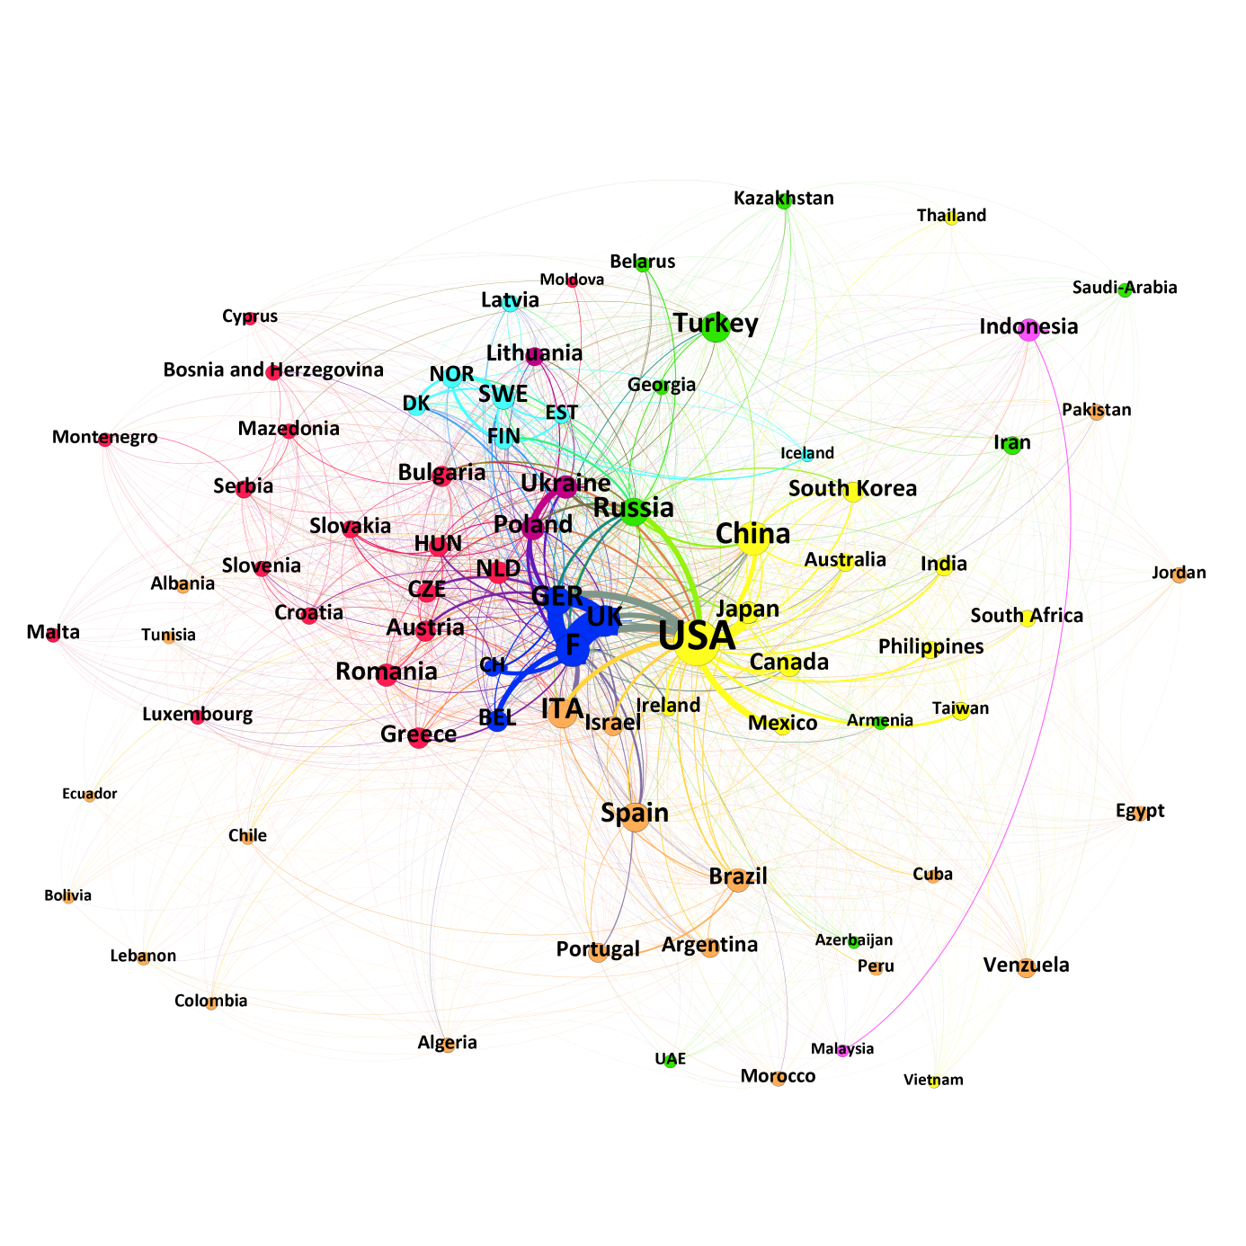

Figure 2: International network of twinnings

|  |  |  |  |  |  |  |
| --- | --- | --- | --- | --- | --- | --- |
|  | Weighted Degree | Closeness | Betweenness | Eigenvector | Thickest Connections | |
| 1 | USA | USA | USA | USA | France – UK | 899 |
| 2 | France | China | UK | France | France – Germany | 505 |
| 3 | Germany | France | China | China | Germany – UK | 417 |
| 4 | UK | UK | France | Italy | Japan – USA | 363 |
| 5 | Russia | Italy | Turkey | Russia | Germany – Germany | 330 |
| 6 | Poland | Turkey | Indonesia | Germany | France – USA | 236 |
| 7 | Italy | Spain | Italy | UK | Poland – Ukraine | 228 |
| 8 | Ukraine | Germany | Spain | Spain | Germany – USA | 227 |
| 9 | China | Russia | Taiwan | Turkey | Mexico – USA | 218 |
| 10 | Japan | Brazil | Portugal | Romania | Belgium – France | 178 |

Table 1: Rankings based on network statistics

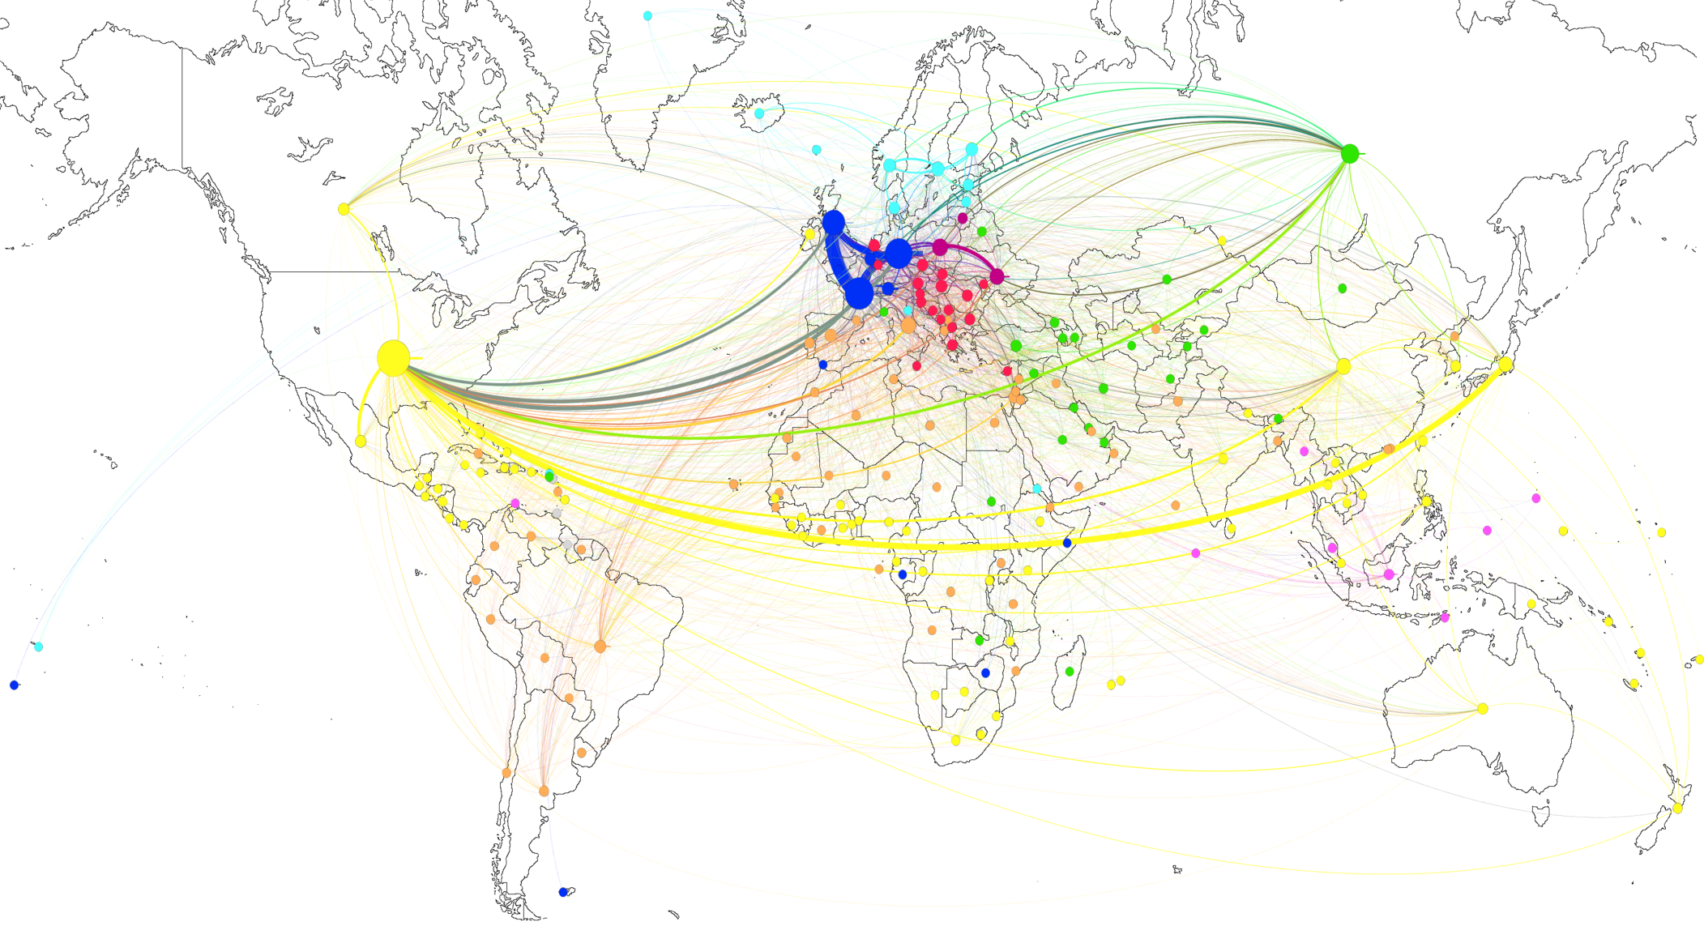

Figure 3: Geographical network of countries. The size of the nodes corresponds to the weighted degrees.

Towards the right of the graph is the yellow network. It is heavily dominated by the overwhelming position of the USA, whose thick connections may have clustered several related countries in this group. Geographically, it spreads out the most. Nevertheless, shared borders, including those across sea might also play a role as two subgroups are formed by the North American and the East Asian countries. Few countries of this group are isolated in that view, namely South Africa, Australia and Ireland. What all three of them have in common is that their history is rather distinct from the history of their neighbouring countries. Furthermore, a quite unique religious feature connects all of them: Canada, South Africa, Australia and the USA (Ireland only if one counts both parts) are worldwide among the few Christian countries which have similar shares of Catholics and Protestants in their population. Only Switzerland, the Netherlands and Germany also share this pattern. Additionally, this cluster encloses nearly all countries whose majority of citizens are Buddhists. A further historical linkage between the countries of this cluster is that it connects several enemies of former wars. For example the connections USA-Japan, USA-Vietnam, USA-Philippines, Japan-Philippines, Japan-China, Japan-South Korea. Therefore, this group could also be shaped by former enemies trying to overcome their tensions. However, it is also possible, that this motive is only relevant for some countries and only with regard to some former enemies. The strong connections of the USA, which basically keep the group together, support this view. A further reason is the absence of other former enemies, especially Russia. Cambodia is also in that cluster but its linkages are too weak to appear in the graph. In conclusion, this group is very heterogenous and difficult to explain ad hoc.

The next cluster to discuss is the green one. It encloses countries of the Middle East, former Soviet states of the Caucasus region as well as Russia and Turkey. Interesting are the latter ones, which are weakly connected to each other despite having many connections in general and high Eigenvector values. This could mean that both countries are competing for influence in this cluster. Turkey is linked with strikingly many countries what allows it to climb to rank 5 in the betweenness-ranking, while in weighted degrees, it reaches only rank 25. Russia obviously pursues a different strategy and forms seemingly strategic preferences through relatively strong connections to countries outside its own cluster and its direct neighbors. Especially close ties exist with the USA, Germany, Ukraine and Finland. Apart from these, close connections exist with former soviet and some Muslim countries. The countries of the Middle East appear to be rather selective in their sister city choices. The United Arab Emirates have no connection at all to countries of the red or the light blue cluster and from the dark blue cluster only with Switzerland. Saudi-Arabia displays a similar pattern: from the three clusters just listed, it only shows a connection to Bulgaria. This explains the cultural-religious divide in this cluster in Christian orthodox and Muslim countries. It is furthermore interesting that some states of this cluster are not connected presumably due to cultural or historical tensions. No twinnings are visible between Saudi-Arabia and Iran, none between Armenia and Turkey and the connection between Turkey and Greece is very thin with only six partnerships.

The light blue cluster is the easiest to interpret. It consists of the extended group of Scandinavian countries and the Northern Baltic region. Similarities of connections of these countries are clearly shaped by geographical proximity and shared history and culture. Sweden and Norway appear to be the driving forces, who also maintain connections to countries outside the cluster, while Iceland has more than four partnerships only with other Scandinavian countries.

The dark blue cluster consists mainly of Central Europe. The group is heavily dominated by the triad of France, United Kingdom and Germany. Switzerland and Belgium are integrated through their close ties with France. The group is also well connected with other neighboring countries in other clusters and the USA. Germany and France are also closely linked with Russia. The main factors that lead to this constellation were probably proximity in geographical and cultural fashion and a long shared and painful history. Especially for Germany, the will to conciliate relations to former enemies through sister cities is clearly visible. Thick links connect it to nearly all of these states. On the other hand, Germany is also economically highly connected to the other states in the cluster and the twinnings could also aim at deepening existing economical relations.

Within the purple cluster are the well connected partners Poland and Ukraine as well as Lithuania. Possible reasons for their similarity could be proximity, a shared history as parts of one Kingdom until the late 18th century and a shared fear of an aggressive foreign policy by Russia. The first reason might be most important as other countries might be missing to support the latter point: Especially Ukraine, the other Baltic countries and Finland, who orientate more towards Scandinavia.

The smallest cluster is as well one of the most interesting. From those countries of the first graph, it only includes the neighbors Malaysia and Indonesia. Both are mutually their most important partners. Despite having relatively few sister cities in general, their portfolio of relations to very diverse countries is interesting. Indonesia is ranked only 37 along weighted degrees, but its betweenness centrality ranks it place 6 of all countries. This shows, that it connects more than most other countries different parts of the network. Proximity, culture and shared history seem to be rather unimportant apart from the link to Malaysia.

4 SECOND STEP: REGRESSION ANALYSIS

The dyadic data set of sister cities used for the network analysis also serves as the dependent variable for the regression analysis. At first sight, there appears to be a problem regarding this dependent variable: It can never take the value zero, which means that the regression analysis can formally not explain *why* local entities in one state cooperate with cities in a foreign country but only *how* *many* cooperation were founded.

However, with regard to the great variance among countries, this problem turns out to be less severe. If one would include all possible pairs with value zero in the analysis, the variable would be heavily skewed as about 75% of all pairs would be zero and the regression analysis consequently nearly meaningless. It is also less of a surprise that especially small countries do not engage in twinnings with other small states on the other end of the world. But if all of these zero-connections would be included, the analysis would rather explain why Germany founded much more sister cities than Vanuatu. The results would be relatively trivial. If one only takes connections greater than zero, the analysis rather explains why Vanuatu has a twinning with Micronesia but not with Germany. This is much closer to the initial research question. Furthermore, a single sister city connection between two countries is not an impressive feature on the national level and is thus more difficult to be explained by macro variables. In fact, only after a certain number a clear connection between two states is visible. This makes the rising of numbers much more interesting than the difference between zero and one twinning.

The following section explains how the outlined variables were translated to measureable operators.

DETERMINANTS FOR THE FOUNDATION OF TWINNINGS

All of the described variables were included in a regression analysis. Table 2 lists the results. For the first model, all variables were included separately to estimate their highest possible explanatory power; only the religious indices were included all together. For the second model, all variables were included at once. In the third model some outliers, which might heavily influence the results, were excluded. These were all cases with one country being one of the ‘top4’, namely USA, the United Kingdom, France and Germany.

As all variables (except the trade relation) were standardized on 0 to 1, the coefficients can be interpreted as the rise in partnerships from the minimum to the maximum value of this variable. In case of the shared border variable, this means for example: If two countries share a direct land or river border, one would expect 24 partnerships more than between states without any shared border. However, this coding makes the constant term unrealistic and it turns negative. This is the theoretical value for countries that have nothing in common with each other, which has no empiric representation in the dataset.

Many variables reach statistical significance on the 99% level. A shared border leads – as expected – to more partnerships. Hypothesis 1 is thus confirmed. If other variables are included additionally, the values decrease. This might be related to the fact that geographically close countries are also more likely to engage in war or trade and that their religious composition is also more similar. Therefore these variables are probably not independent from each other and might decrease each others´ values.

|  |  |  |  |  |  |  |
| --- | --- | --- | --- | --- | --- | --- |
|  | **Model 1: Separate** | | **Model 2: Complete** | | **Model 3: exclud. top4** | |
|  | Coeff. | Sig. | Coeff. | Sig. | Coeff. | Sig. |
| Border | 24,166  (2,651) | *** | 9,605  (3,128) | *** | 8,406  (1,102) | *** |
| War | 142,889  (12,78) | *** | 105,567  (13,91) | *** | 18,693  (5,153) | *** |
| Colonial history | 1,925  (,008) |  | -3,878  (3,262) |  | ,791  (1,357) |  |
| Independence through organized violence[7] | 6,400  (4,366) |  |  |  |  |  |
| Trade | 48,155  (4,982) | *** | 48,154  (6,560) | *** | 19,153  (2,320) | *** |
| Religion | 10,946  (2,260) | *** | 7,977  (2,216) | *** | 1,798  (,780) | ** |
| Cristianity | 2,444  (2,452) |  |  |  |  |  |
| Islam | 1,323  (4,354) |  |  |  |  |  |
| Judaism | 5198,3  (744,9) | *** |  |  |  |  |
| Buddhism | - ,315  (22,63) |  |  |  |  |  |
| Hinduism | -5,938  (73,07) |  |  |  |  |  |
| Non-religious | 104,906  (15,24) | *** |  |  |  |  |
| Constant term |  |  | -30,356  (4,526) | *** | -9,936  (1,586) | *** |
| N | >=1724 |  | 1724 |  | 1350 |  |
| Consolidated R² | <=0,078 |  | 0,114 |  | 0,170 |  |
|  |  |  |  |  |  |  |

Table 2: Regression results, dependent variable: Number of sister cities[8]

Wars between two countries do indeed lead to more sister cities between the enemies. The analysis does support the reconciliation hypothesis (H2a). The surprisingly high coefficient of 105 in model 2 might indicate that this variable is especially influenced by relations between the ‘top4’ (USA, United Kingdom, France and Germany). Therefore model 3 was calculated without the connections of these countries. As expected, the coefficient then drops to only 18.7. However, it is still positive and thus indicates, that the reconciliation strategy through twinnings is adopted not only by the prominent example of Germany and France.

In theory, it could also be true, that countries pursue that strategy only after moderate conflicts and that it becomes more difficult as the fatality level increases. This non-linear relationship was tested separately in models that are not reported here through a squared term of a zero-centered version of the war variable. In fact, the coefficient was significant and negative, which indicates that severe conflicts as well as no conflicts at all lead to fewer partnerships between countries. However, the coefficient and the explained variance were lower than in the reported models, no matter if the ‘top4’ were included or not.

Quite surprisingly, the colonial history of a dyad plays no significant role in explaining twinnings between two states. If independence was reached through organized violence or not is also rather irrelevant. This result is in strong contrast to the result of the network analysis. A possible explanation could be that the relatively great number of colonial relations in the data set (105) does cover up effects of well-known dyads that were visible in the network.

On the contrary, trade does play a decisive role. The coefficient is hard to interpret after the logarithmic transformation but the fact that it does not lose any strength when the other variables are included proves that it is indeed relevant. Similar to the war variable, its value also decreases heavily when the dyads of the ‘top4’ are excluded from the model.

The religious composition is also quite influential in explaining twinnings. When controlling for other variables it decreases. If also the ‘top4’ are excluded, it drops to the very low value of only 1.8. This is quite interesting, because it means that countries that are 100% similar in their religious composition have only – at best – 11 twinnings (Model 1) more with each other than countries which are completely different.

The religious index consists of the five separate indices. If split, it turns out, that the effect rests mainly on the similarity in Jewish and non-religious population shares. The first is easily explained. Israel is very unique in its composition. It did also found many sister cities but nearly exclusively with countries that have a low, but at least measureable share of Jews in their population (especially the USA, Germany and France). This makes the model expect the highly unrealistic number of 5198 partnerships if Israel had an exact ‘double’. The high value for the non-religious might be especially related to the Central and Eastern European countries, where many of the most secular countries of the world can be found (foremost the Czech Republic, Estonia, Latvia, Germany and the Netherlands). Those are also well connected. Somewhat irritating is the low and insignificant value for the share of Muslims. These states were one of the main reasons, this variable was included (green cluster in Graph 1). Even if it is the only variable included in the regression (model not reported) its value does not reach the 95% level of significance.

The consolidated R² reaches 17% of explained variance, which is rather low considering the aspiration of this paper to comprehensively explain why sister cities are founded. Probably this result is related to the state level whose factors are less relevant than assumed in the beginning or some highly relevant features were not included so far. One could think for example of other cultural variables like a common language or other patterns of cooperation, as for example the membership in international organizations.

The initial research question if sister cities are ways to deepen existing relations or founding new ones can be answered now. The result appears unambiguous at first. All variables have positive signs, therefore more contact or similarity means more twinnings. A prove for the deepening hypothesis. However, there are limitations of this interpretation: former combatants have more connections than peaceful dyads. Similar religious compositions are less relevant and former contacts through colonial relations are nearly irrelevant.

The result is thus more ambivalent than it first appears. It seems that sister cities are a way to bridge direct borders and deepen existing economic relations. Wars in the past or different religious compositions are nevertheless no obstacle to such cooperation.

SUMMARY AND CONCLUSION

Sister cities are a phenomenon of international politics on sub-national level and that makes them an exciting field of research. However, this two-layered structure also makes their quantitative study more difficult. Collecting city-based data on a worldwide scale would be very difficult and structural bias is very likely. Thus, in this paper, only national data was employed. The research question was: Which national factors can explain the establishing of sister city partnerships between two countries? And: Are sister cities mainly founded to deepen existing contacts or to establish new contacts?

Initially, several potentially important factors which could influence the number of twinnings between two countries were identified theoretically and according hypotheses were formulated. Those factors were: Shared borders, former wars or colonial history, similarity of religious composition and trade.

A graphical analysis using social network theory also showed, that the partnerships of a few countries, especially the USA, the United Kingdom, France and Germany, already account for a major share of all twinnings worldwide. The clustering of countries in gave more hints to the underlying factors for establishing twinnings. Especially regional proximity, historical and cultural reasons appeared to play a crucial role. Furthermore, exceptional features of some countries were discussed in that part.

To test the derived variables, a regression analysis was performed. Except for the colonial history, all variables significantly influenced the number of partnerships between two countries. More wars, more trade, more direct borders and a more similar religious composition of the population all lead to more sister cities. When the outlier values of the ‘top4’ (USA, UK, Germany and France) were excluded from the analysis, the coefficients were reduced in scale as expected. However, the ‘positive’ effect of wars was still visible even when the reconciliation policies of these four countries were excluded.

Along these results, it is possible to draw a conclusion regarding the second research question. Sister cities indeed serve the deepening of existing trade cooperation and the overcoming of direct borders. Nevertheless, religious similarity or a peaceful past are secondary factors. Insofar, twinnings also serve the establishing of new contacts and the reconciliation with old foes – not only between the big industrial countries.

The analysis also revealed methodological problems in studying sister cities. First of all, they are difficult to measure. To the author´s best knowledge, there exists no worldwide data bank for such connections. Furthermore, it is not possible to measure how important a connection is for the two cities. Are there regular student exchanges or no contact at all? Are there differences in power and one city is depending more on the partnership than the other? Are there informal contacts which are probably more important than formal ones? Does the ideological background of the city council or the mayor matter? Is, for example a conservative party in Germany less enthusiastic in forming ties with Russia than a party of the far left? Are there national guidelines or bans regarding potential partners?

All these questions cannot be answered by a quantitative research like the one in this paper. From this perspective, the relatively low explained variance is less of a surprise. The discipline of political science might be well-advised to study this interesting field through qualitative and quantitative research to develop an comprehensive – also theory-based – model for explaining the phenomenon of sister cities.

# Literature

Bastian M., Heymann S., Jacomy M. (2009). Gephi: an open source software for exploring and manipulating networks. International AAAI Conference on Weblogs and Social Media.

Baycan-Levent, Tüzin; Gülümser Akgün, Aliye Ahu; Kundak, Seda (2010): Success Conditions for Urban Networks. Eurocities and Sister Cities. In: *European Planning Studies* 18 (8), S. 1187–1206. DOI: 10.1080/09654311003791259.

Cremer, Rolf D.; Bruin, Anne de; Dupuis, Ann (2001): International Sister-Cities. Bridging the Global-Local Divide. In: *Am J Economics & Sociology* 60 (1), S. 377–401. DOI: 10.1111/1536-7150.00066.

City of Rome (2016): Roma-Parigi, 60 anni di gemellaggio. Cerimonie e luci sulla città. Available at https://www.comune.roma.it/pcr/it/newsview.page?contentId=NEW1036245, last checked on 7.8.16.

Fink, Simon; Rempe, Daniel; Obermeier, Axel (2010): Indicators for economic power and dependence - working paper.

Griffin, Mary (2011): What is the point of Coventry's twin towns? In: *Coventry Telegraph*, 02.08.2011. Available at http://www.coventrytelegraph.net/news/local-news/what-point-coventrys-twin-towns-3038605.

Hensel, Paul R. (2014): ICOW Colonial History Data Set, version 1.0. Available at http://www.paulhensel.org/icowcol.html, last checked on 29.07.16.

Hofstede, G., Hofstede, G. J., & Minkov, M. (2010): Cultures and organizations: Software of the mind, third edition (3rd ed.). McGraw-Hill Professional.

Huntington, Samuel P. (1997): Der Kampf der Kulturen. Die Neugestaltung der Weltpolitik im 21. Jahrhundert. 4. Ed. München [u.a.]: Europaverlag.

International Trade Centre (ITC) (2016): Trade Map. Available at http://www.trademap.org/Country_SelProduct_TS.aspx?nvpm=1|||||TOTAL|||2|1|1|1|2|1|2|1|1, last checked on 7.8.16.

Jacomy, Mathieu; Venturini, Tommaso; Heymann, Sebastien; Bastian, Mathieu (2014): ForceAtlas2, a continuous graph layout algorithm for handy network visualization designed for the Gephi software. In: *PloS one* 9 (6), S. e98679. DOI: 10.1371/journal.pone.0098679.

Kaasa, A.; Vadi, M.; Varblane, U. (2016) A new dataset of cultural distances for European countries and regions. Research in International Business and Finance, 37: 231 - 241. DOI: 10.1016/j.ribaf.2015.11.014.

Kaltenbrunner, Andreas; Aragón, Pablo; Laniado, David; Volkovich, Yana (2013): Not all paths lead to Rome. Analysing the network of sister cities.

RGRE (Rat der Gemeinden und Regionen Europas) (2016): RGRE-Partnerschaften. Available at http://www.rgre.de/partnerschaften0.html, last checked on 29.07.16.

Schwartz, Shalom (2008): The 7 Schwartz cultural value orientation scores for 80 countries. 10.13140/RG.2.1.3313.3040.

Sister Cities International (SCI) (2016): City Search. Find your city´s sister! Available at http://www.sister-cities.org/, last checked on 29.07.16.

Stadt Bamberg (2016): Feldkirchen. Topografie und Geschichte. Available at https://www.stadt.bamberg.de/index.phtml?La=1&sNavID=1829.24&mNavID=1829.376&object=tx|1829.615.1&kat=&kuo=1&sub=0, last checked on 6.8.16.

Stadt Hallstadt im Landkreis Bamberg (2011): Broschüre zur Städtepartnerschaft mit Hallstatt am See. Available at http://www.hallstadt.de/index.php?id=2559,158.

Ude, Christian (2012): Städte als außenpolitische Akteure. In: *Z Außen Sicherheitspolit* 5 (1), S. 11–18. DOI: 10.1007/s12399-011-0238-z.

World Bank (2016): Explore. Create. Share: Development Data. Available at http://databank.worldbank.org/data/home.aspx, zuletzt geprüft am 7.8.16.

Zelinsky, Wilbur (1991): The Twinning of the World. Sister Cities in Geographic and Historical Perspective. In: *Annals of the Association of American Geographers* 81 (1), S. 1–31. DOI: 10.1111/j.1467-8306.1991.tb01676.x.

1. In fact, also Paris and Rome have more sister cities than just this one. However, those are not labelled as friendships. Despite these nuances, this paper will treat all such relations as equal. The terms ‘sister cities’, ‘twinnings’, ‘partnerships’ and ‘cooperation’ are used as synonyms for the same concept.
2. This graph is based on the graph by Zelinsky 1991, p. 19. Only values above the corresponding median are reported. Map layout from wikipedia.org.
3. Ude names the relations between China and Germany as an example: „[…] when intergovernmental relations came to a halt in 1989, the federal government of Germany […] saw the opportunity for Chinese people to keep in touch with the West through communal contacts.” (Ude 2012, p. 15–16, translated by the author)
4. Kaltenbrunner et al. (2013), as well as Bussmann and Nickel (2018) use city based distance measures, but aggregate to the national level when other variables are involved.
5. Kindly provided by Andreas Kaltenbrunner, [Eurecat - Technology Centre of Catalonia](http://eurecat.org/en/), Barcelona (Spain).
6. Data was obtained from the World Bank (2016).
7. Only the 105 cases of colonial relations were relevant for the estimation of this coefficient.
8. The first model displays seven models at once. In every of those only one of the variables was included. The table lists unstandardized regression coefficients. Standard errors are listed in parantheses. Significances: *** p<0,01; ** p<0,05; * p<0,1.